**Savoy Ballroom**

The Savoy Ballroom, Harlem’s largest and most famous ballroom during the Swing Era, was nicknamed ‘The Home of Happy Feet’. After it opened in 1926, it became one of the most cosmopolitan places in the world, artistically speaking, where intersecting popular music genres, and racial and class divides, opened a space for personal creativity. Unlike most other ballrooms in Harlem and throughout the country, it had an open admission policy from the beginning and, as a result, its clientele was integrated—mixing classes, ethnicities, and races. It pioneered the ‘battle of the bands’ format, in which two orchestras would alternate sets, competing for the audience’s favour. It held weekly dance competitions, sharpening the skills and appetites of the dancers who were the bands’ principal audience. These activities helped make the Savoy a catalyst for innovation, and it was especially known for its Lindy Hop (aka Swing or Jitterbug) dancing, which embodied speed, individuality, physical feats, and African diasporic influences.

In 1925 Sigmund Galewski (Gale), a Polish-Jewish immigrant in the leather business, was approached by a family connection in real estate about the possibility of opening a Harlem version of the Roseland Ballroom in midtown Manhattan. Sigmund turned it over to his son Moses (Moe), who recruited Charles P. Buchanan, a Harlem businessman, as manager. The two lavishly furnished the ballroom, and chose the name “Savoy” for its resonance of old-world splendor. The ballroom opened on Friday night, March 12, 1926, on Lenox Avenue between 140 and 141st streets. Entering beneath its brightly lit marquee, a visitor could descend a flight of stairs to the checkroom, continue to the main lobby, or ascend a marble staircase to the ballroom proper, which easily held 2,000 people. Alongside the dance floor were two bandstands: one for the house band, the other for the visiting band. Booths lined the walls, and at one end was a lounge and a soda counter. Until the early 1940s the Savoy followed the traditional ballroom practice of offering ‘hostesses’ who would dance with male guests for twenty-five cents a dance, if they were shy or insecure about dancing. Aware that a scandal could easily close the ballroom, especially at a mixed-race institution, Buchanan kept close watch on hostesses and bouncers, and their interactions with customers.

The Savoy was not the only ballroom in Harlem, but stood out because it attracted the very best bands and dancers. Visitors were drawn by the 50’ x 200’ sprung maple dance floor, which spanned virtually the entire upstairs and was kept fastidiously clean. In addition, there was a special bond between musicians and dancers that grew over time. The ballroom was often visited by celebrities – including Greta Garbo and Clark Gable – who knew that they would not be pestered by autograph-seekers. The ballroom was also thoroughly integrated into Harlem’s community life. It hosted numerous benefits for causes and charities, including the Scottsboro Defense Fund and the National Urban League’s Annual Beaux Arts Ball. At one point the ballroom even had a basketball team that benefitted the local Boys’ Club.

The Savoy was a crucible for the emerging big dance bands of the Swing Era, as well as for the development of the popular dance of the day. Virtually every major band of the Swing era played the Savoy, and many film clips exist of both the music and the dancing. In the mid-1930s the Savoy’s then-house band, the Chick Webb orchestra and its fledgling singer Ella Fitzgerald, was signed for weekly coast-to-coast radio broadcasts by NBC, a breakthrough for black musicians in America. Famous musical moments include battles of the bands between Chick Webb’s and Benny Goodman’s orchestras on May 11, 1937, and between Webb’s and Count Basie’s band on January 16, 1938. In 1939, the Savoy opened an exhibition at the World’s Fair, with dance performances several times an hour, and its dancers were regular winners of the Lindy competitions at the Harvest Moon Ball, a popular New York City-wide dance competition sponsored by the New York *Daily News*. In 1940, it was estimated that the total Savoy attendance during the previous 14 years was 10,160,000, and that the ballroom had grossed about $5,000,000, $2 million of which had gone to pay the house bands alone.

In the early 1940s, the Savoy came under pressure from the New York City police, increasingly uncomfortable with social institutions that mixed races. In 1940, the ballroom was forced to discharge all of its dance hostesses to prevent charges of supporting prostitution, though downtown ballrooms on Broadway were permitted to continue this practice. Desperate to keep the Savoy open, Buchanan also stopped selling liquor for a while, despite his possession of a permit to do so. The ballroom even ceased advertising in white papers, and stopped booking popular white bands, in an effort to avoid unwanted attention. In April 1943, however, the police succeeded in having the ballroom closed for several months on what were vaguely termed ‘vice charges’, though Harlem leaders were surely correct in saying that the real reason was the ballroom’s refusal to ban interracial dancing. Changing economic, musical, and demographic trends eventually made ballrooms much harder to operate as businesses after the Second World War. In 1958, the ballroom’s land was taken over by sponsors of an urban renewal housing project. Buchanan wanted to relocate the ballroom elsewhere and vainly tried to convince the sponsors to find another site for it. The Savoy closed on July 10, 1958. Its fixtures were auctioned off, and it was torn down and replaced by a mid-income apartment complex.

A plaque now marks the spot where the Savoy once stood in Harlem. The ballroom is now recognized as a key institution in the long journey towards greater racial integration in America. It was also important for its long-term impact on popular music and dance practices around the world, as swing music and the Lindy Hop eventually traveled the globe as ambassadors for the United States, African-American culture, and North American modernity.

Robert P. Crease

**References and Further Reading**

Hubbard, K. and T. Monaghan, (2008) ‘Negotiating Compromise on a Burnished Wood Floor: Social Dance at the Savoy’, in *Ballroom Boogie, Shimmy Sham Shake*, ed. by J. Malnig. University of Illinois Press.

Manning, F. with C. Millman, (2007) *Frankie Manning: Ambassador of the Lindy Hop*. Philadelphia: Temple University Press.

Miller, N. with E. Jensen, (1996) *Swingin’ at the Savoy: The Memoir of a Jazz Dancer*. Philadelphia: Temple University Press.

Stearns, M. and J. Stearns, (1994) *Jazz Dance: The Story of American Vernacular Dance*. New York: Macmillan; repr. Da Capo.

**Motion Picture Documentation**

*The Savoy King: Chick Webb and the Music that Changed America*, film, 2012.

**Paratextual Material**

<https://www.youtube.com/watch?v=Mqsc0dhoED0>

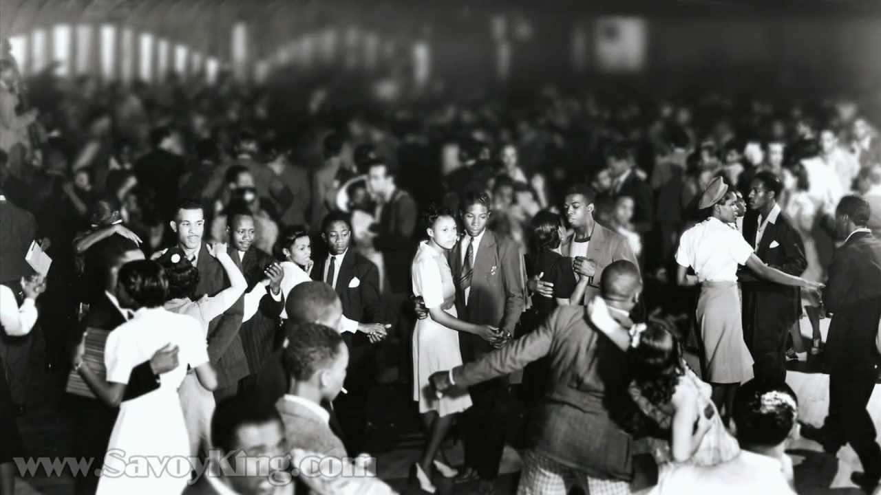

<http://www.swingmusic.net/Swing_Music_Chick_Webb_Cuts_Count_Basie.html>

